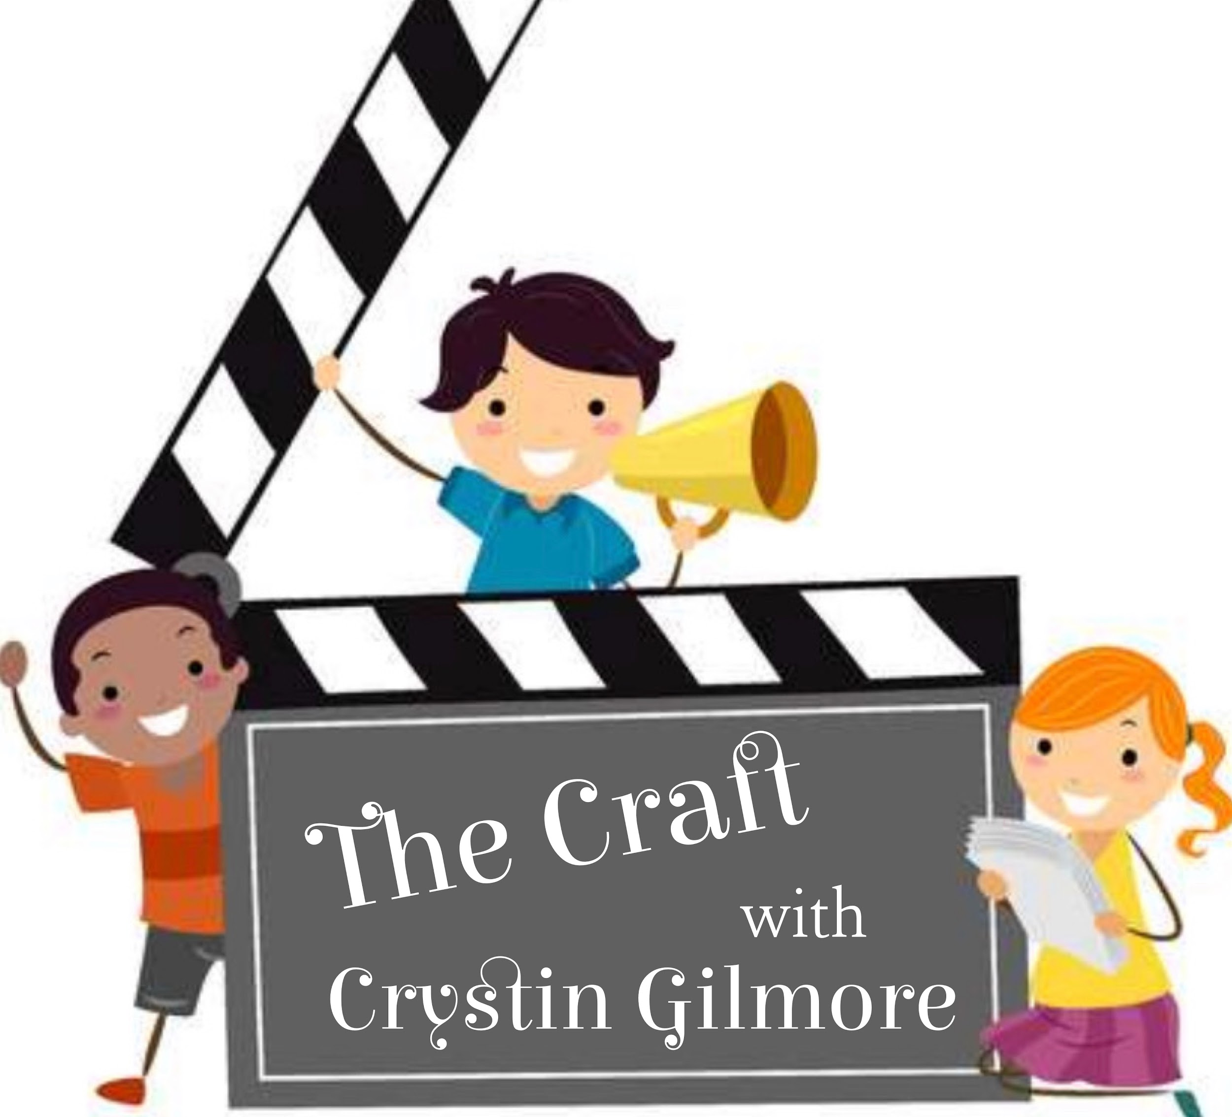

Individual Actor Training

An 8 Week One on One Intensive
* 2-3 One hour sessions a week via Zoom

OBJECTIVE:
To prepare your child for a career in acting.
Provide the tools you need to execute an audition using improvisation and/or a memorized script.
Assist in getting comfortable and confident in a room with casting agents and directors.
Help prepare your brand and marketability.
Guide you through the steps needed to submit to casting agencies and open calls.
Weekly homework will assist in the preparation for the next session.

CURRICULUM:
Week 1: What is acting and what are you selling?
- We discuss what an actor does. The different fields of acting and what interests your child the most.
- We delve into what your child’s “brand” is. With branding, we discuss personality and characteristic traits. What your child enjoys doing and excels at. This helps in how we market your child and present them when it comes time to take headshots.
- We discuss the 4 acting techniques and decide which one best suits you.

Week 2: The makings of a stage play & the players.
- Discuss theatre terminology and stage directions such as upstage, downstage, stage left, stage right, the green room, breaking the 4th wall, props, costumes, being on book and off book, taping a stage, stage wings,
- Discuss the people involved in a theatre production cast and technical crew, etc.
- Discuss actor etiquette in the rehearsal process and actor homework

Week3: Acting for TV and Film/ How it differs from Theatre
- Discuss TV and Film terminology and how it’s set up ex: a roll sheet, how to check for your call time and location. Your direct person of contact, what to bring and what to wear. How to arrive prepared. What is craft services? The holding room. What to do during down time. Hair and make up. How to interact with the crew. X or T marks the spot
- Discuss the people and crew in a TV or Film production ex: the producer, director, assistant, director, make up artist, costume designer, lighting grips, camera men, cast members, etc.
- Discuss the difference between acting for the stage and acting for the camera- specificity, repetition and tight camera angles vs big bold movements, variety and clarity

Week 4: Vocal warm ups and physical movement
- Introduction to tongue twisters, vocal warm ups and physical warm ups
- We will work on Acting with the body, discuss the 5 senses and how they relate to our acting choices. Touch, taste, feel, hearing & sight
- Discuss How acting is related to our memory of what we’ve seen, experienced, felt, tasted and heard. How our reactions produce great acting moments.

Week 5: Let’s meet the script
- It’s time to pick a script and get on our feet. I will give you a script to look over and we will work on it.
- Previous story:We will create and/or come up with your character’s previous backstory. Where they are from. How many siblings do they have? How old are they? What’s their favorite thing to do? To eat? What they look like. What has lead up to the moment before the script’s action.
- Action words. We will discuss the words that motivate you to act. I want to persuade, convince, pick on, provoke, harm, share, etc.

Week 6: Memorization & Character development
- It’s time to start memorizing the script. I will walk you through the many memorization techniques. - written, reading it and saying it aloud, memorizing it with blocking for the camera and for theatre
- We will start to develop your character's characteristics. How it moves, speaks, mannerisms, how it laughs, cries and walks, what would the character wear?
- Time to put the two together. We will work on being off book for the next session.

Week 7: On our Feet and audition ready- what to expect when you walk in the audition room
- The theatre set up
- The tv/film set up for casting agents
- How to self tape and slate

*Week 8: Time to make a reel- All face to face sessions
-This week we prepare to self tape : the outfit for the audition that best suits your character
- The camera angles and where to stand for your face to face audition for theatre or film
- We tape your audition with lights in a studio space

Rate:
-$75/session
- * An option to Add: A showcase:
- Invite family and friends to watch your monologue, scene with a scene partner and song if applicable with an accompanist or audio.
- An accompanist, Studio rental & 1 minute reel with full edits are an additional $600

Feel free to contact me with any questions!

Crystin Gilmore
crystingilmore@gmail.com

